Notice of Visiting Non-Member to Union Assembly
Meeting and date: | Union Assembly, Tuesday 4 February 2025
Purpose of paper: | To give advance notice of a visitor to February’s UA
Intended outcome: | For Information
Paper submitted by: | Cerys Evans, Students’ Union President
Restricted business: | Restricted
Key contact(s): | Cerys Evans (she/her)  Students’ Union President  email: lusu.president@lancaster.ac.uk
Persons/committees consulted to date including student engagement (where appropriate): | Full-Time Officer Group  Chair and Vice-Chair of Union Assembly
EDI | If any members feel uncomfortable with the presence of this visitor for any reason then please alert the Chair of Union Assembly and the Students’ Union President ahead of the meeting so that a resolution can be discussed. If an issue arises during the meeting, please make the Chair of Union Assembly aware in the usual way.
Date paper produced: | 22 January 2025

Overview
Adrian Jonas, a governor of the University and lay member of Council will be visiting the Union Assembly meeting taking place on the 4th of February.
Adrian is a member of Council which is the highest decision-making body in the University. I’ve worked with Adrian for 18 months and he has repeatedly demonstrated a genuine interest in understanding the experiences and needs of students and then speaks in support of the things that students have said that they want – I would say that he’s a strong ally for students and for the Students’ Union.
This is an opportunity for him to see how student voices inform the work we do at the Students’ Union and to better understand the function and purpose of UA. His visit to UA will follow meetings with small groups of students to hear about student issues

Who is Adrian?
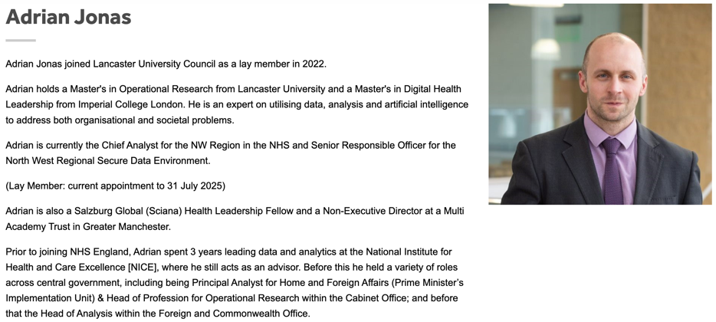
(Taken from https://www.lancaster.ac.uk/strategic-planning-and-governance/governance/council/members/)

Why is he important at Lancaster University?
The University describes Council as: “the governing body of the University. It is the legal entity and ultimate authority of the University and it is unambiguously and collectively accountable for institutional activities, taking all final decisions on matters of fundamental concern within its remit.”
The University says that: “Members [including Adrian] need to be satisfied that processes and procedures are in place which are sufficient and effective in running the business of the University.”
You might find it helpful to have a scan through the items that have been discussed at Council recently, this is probably the easiest way to understand the breadth of what is covered and what kinds of topics are relevant to Council members: https://www.lancaster.ac.uk/strategic-planning-and-governance/governance/council/#minutes-of-council-489091-2

What authority/power does he have?
Council makes decisions as a collective, this means that members work together to make decisions in the best interests of the University. Every member of Council has an equal voice and an equal vote in any decision, this means that any one member does not have individual authority but instead uses their voice to advocate for a position.
Therefore, Adrian does not have individual power to change any policy or decision made by the University nor is it his job to investigate or give a stance on any individual issue. His reason for visiting is to hear what is important to students and to give an opportunity for students to better understand the work of Council lay members and Council as a whole.

