Question Of the Week – Week 16
How would the Introduction of self-certifications impact you in your studies?


Report Written and Collated by:
Emmanuella Obour, LUSU Insight Research Assistant

Lancaster University Students’ Union
February 2024

Introduction
This report delves into the findings of a survey conducted among the student population at a university regarding the proposed introduction of self-certifications for coursework extensions. The primary focus of this initiative is to understand the potential impact of allowing students to self-certify for an automatic four-day extension on coursework assessments, with the possibility of applying for up to three self-certifications per academic year. The self-certification process is designed to accommodate students facing exceptional circumstances, including mental, physical health issues, personal dilemmas, or inadequate IT resources. With 75 responses collected, the survey aimed to capture a broad spectrum of student perspectives on how such a policy might affect their academic experience and study habits.
Methodology
Research Design
The survey employed a mixed-methods approach, combining quantitative and qualitative research methodologies to gather a comprehensive understanding of students' views on the introduction of self-certifications. This design facilitated an in-depth exploration of the topic, allowing students not only to provide binary (yes/no) responses but also to elaborate on their opinions through open-ended questions. This approach enabled the collection of rich, nuanced data on students' experiences and expectations regarding self-certifications.
The data collection was executed using Microsoft Forms, chosen for its accessibility and ease of use, which promoted broad participation among the student population. The survey questions were thoughtfully designed to probe into the essential aspects of the self-certification policy and its perceived impact on students' study habits and mental health.
Methodology
The survey included two primary questions:
- "How would the introduction of self-certifications impact you in your studies?" - This open-ended question allowed students to provide detailed responses, reflecting on how the policy could affect their academic strategies, mental health, and overall study experience.
- "Have short-term mental health conditions impacted your ability to study?" - Offering a binary choice of "yes" or "no," this question aimed to quantify the prevalence of mental health issues affecting academic performance among the respondents.
The survey was advertised through the Lancaster University Students' Union (LUSU) WhatsApp group chat and various social media platforms, ensuring a wide reach and diverse participation. To incentivize participation, the survey was promoted with the offer of freebies and entry into a prize draw, with the week's prize being a £30 Greggs Gift Card. This strategy was designed to enhance engagement and ensure a diverse range of responses, contributing to the richness of the data collected.
Methodological Limitations
While the mixed-methods approach enriched the survey's findings, several limitations must be acknowledged. Firstly, the incentive-based participation might introduce a bias, attracting responses primarily from students motivated by the rewards rather than interest in the policy discussion. This could affect the representativeness of the data. Additionally, the reliance on self-reported data, particularly in responses to the open-ended question, may introduce subjectivity into the findings. Students' perceptions of the impact of self-certifications on their studies could vary widely, influenced by individual experiences and circumstances, which may not fully capture the policy's overall effect.
The sample size of 75 respondents, while providing valuable insights, represents a small fraction of the broader student body. This limits the generalizability of the findings, necessitating further research to corroborate these preliminary results across a more extensive and varied student population. Despite these limitations, the survey offers crucial preliminary insights into student attitudes towards the proposed self-certification policy, highlighting its potential benefits and areas of concern. This feedback is invaluable for informing the university's approach to supporting students' mental and physical health needs while maintaining academic integrity and standards

Analysis and observation
1.How would the introduction of self-certifications impact you in your studies?

The survey conducted to explore the potential impact of introducing self-certifications for coursework extensions at a university has yielded a wealth of insights from the student body. Analyzing the responses from 75 participants reveals several key themes, trends, and sentiments that provide a comprehensive understanding of how such a policy might influence student studies, wellbeing, and academic performance. This analysis critically examines the collected data, highlighting notable quotes and identifying commonalities and divergences in student opinions.
Key Themes and Trends

Stress Reduction
A dominant theme emerging from the responses is the potential for self-certification to significantly reduce stress associated with academic deadlines. Many students express that the flexibility and autonomy offered by self-certification could alleviate the pressure and anxiety of meeting tight deadlines, especially when facing unforeseen challenges such as illness, personal crises, or technical issues. For instance, one respondent noted, "It would take the stress away from applying for an extension when suffering from a flare-up of illness, a short-term condition, or a few days of poor mental health," highlighting the direct impact on mental wellbeing.
Enhanced Flexibility and Convenience
The aspect of increased flexibility and convenience was frequently mentioned, with students valuing the ability to manage unforeseen challenges more effectively. This sentiment is encapsulated in responses like, "It would certainly provide more convenience and flexibility to me given that I could have been facing issues at an emergency," suggesting that the policy could empower students to better navigate disruptions to their academic work.
Concerns Over Potential Abuse
While many responses were positive, there was also a concern among some students that the self-certification system could be susceptible to abuse. A respondent cautiously pointed out, "However, I think this could easily be abused by people not really needing extensions and just using them for the sake of using them," indicating apprehensions about the policy's potential to undermine academic integrity if not carefully managed.
Mixed Opinions on Impact
A smaller subset of students expressed ambivalence or neutrality regarding the impact of self-certifications on their studies. For example, one student stated, "Unlikely to impact my studies," suggesting that the effectiveness and relevance of the policy might vary significantly among the student population, depending on individual circumstances and academic disciplines.
Recognition of Specific Needs
Several responses highlighted the importance of acknowledging and accommodating specific needs, such as mental health issues and learning differences. This is exemplified by a student's remark, "Between mental health issues and problems with time management related to neurodiversity, I often struggle to hand things in for the deadline," underscoring the potential of self-certification to provide critical support for students with diverse needs.
Notable Quotes
- "It would reduce some sort of level of stress when it comes to coursework submission. As a foreign student, sometimes the deadlines can be challenging to reach because of my different learning levels in specific areas."
- "It would make gaining an extension much easier as the usual process is so stressful and trying to gain one when already stressed makes it really difficult."
- "Why is self-certifying needed if they fall under the same criteria as when staff give out extensions? They're still being given a timeframe to do them by, so it doesn't feel like a necessary change."

These quotes exemplify the broad spectrum of perspectives, from strong support for the policy as a means to reduce stress and accommodate diverse student needs, to skepticism about its necessity and potential for misuse.
Observation
The data indicates a strong overall consensus among students that the introduction of self-certifications could have a positive impact on their academic experience, primarily by reducing stress and increasing flexibility in managing coursework deadlines. This trend suggests a significant portion of the student body may be struggling with the current systems in place for granting extensions, finding them to be inflexible or overly burdensome. However, the concerns over potential abuse highlight the need for clear guidelines and limitations to prevent exploitation of the policy. This suggests that while students are in favor of more autonomy, there is also an awareness of the importance of maintaining academic standards and fairness.
The mixed responses regarding the direct impact of self-certifications on individual studies reflect a diverse student population with varying needs, academic disciplines, and personal circumstances. This diversity underscores the challenge of implementing a one-size-fits-all policy and highlights the importance of flexibility and adaptability in its application. Furthermore, the emphasis on specific needs, particularly regarding mental health and neurodiversity, points to a broader issue within academic institutions regarding the support and accommodations available to students facing these challenges. Implementing self-certification could be one step toward addressing these needs, but it should be part of a comprehensive strategy that includes additional support services and accommodations.
2.Have short term mental health conditions impacted your ability to study?

The survey conducted to understand the impact of short-term mental health conditions on students' ability to study revealed that a significant portion of the student population at a university is affected by these issues. With 77 responses, 52 students confirmed that their study capabilities had been impacted by short-term mental health conditions, translating to approximately 67.5% of the respondents. This data is crucial as it sheds light on the pervasive nature of mental health challenges within the academic context and their tangible effects on students' academic performance.
The majority's acknowledgment of the adverse effects of mental health conditions on their ability to study signals a critical need for attention and action within educational institutions. This high percentage is indicative of a broader trend in higher education, where mental health issues are becoming increasingly recognized as significant barriers to academic success. It emphasizes the necessity for universities to implement supportive measures and resources to address these challenges effectively. The findings from the survey underscore the complexity of mental health issues and their direct correlation with academic performance. Students dealing with mental health conditions may face difficulties such as decreased concentration, motivation, and productivity, which can severely hinder their academic progress and overall university experience. This situation calls for a nuanced understanding and approach from educational institutions to provide adequate support and accommodations for affected students.
Furthermore, the willingness of a substantial number of students to acknowledge the impact of mental health issues on their studies may reflect a changing attitude towards mental health, with reduced stigma and increased openness to discussing these challenges. However, it also highlights the ongoing need for creating more inclusive and supportive environments that encourage students to seek help without fear of judgment or repercussions. The implications of these findings are manifold. Firstly, they point to the pressing need for accessible and comprehensive mental health services within universities, including counselling, therapy, and wellness programs, tailored to the diverse needs of the student body. Additionally, academic accommodations, such as the possibility of self-certification for coursework extensions, can offer much-needed relief and flexibility for students navigating the complexities of mental health issues alongside their academic responsibilities. Moreover, the data suggests the importance of ongoing mental health education and awareness campaigns to further destigmatize mental health issues within the university community. By fostering an environment where mental health is openly discussed and addressed, universities can ensure that students feel supported in seeking help and utilizing available resources.
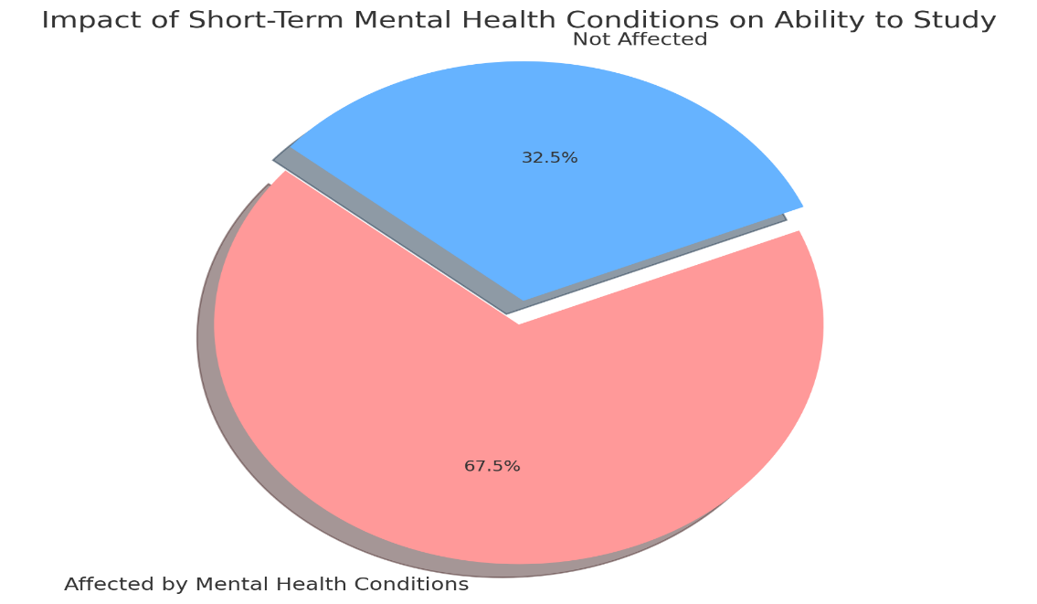

Conclusion
The survey findings underscore the critical need for universities to address the impact of mental health on academic performance and the potential benefits of introducing self-certifications for coursework extensions. With a significant proportion of students affected by short-term mental health conditions, the demand for greater flexibility and support within academic policies is clear. Implementing self-certifications could offer a valuable mechanism for reducing stress and accommodating diverse student needs. However, concerns about policy abuse highlight the importance of establishing clear guidelines. Overall, the survey emphasizes the urgency of enhancing mental health support and academic accommodations to foster a more inclusive and supportive educational environment.

