Scrutiny Report of Atree Ghosh

January 2021
Atree Ghosh, current Vice President of Union Development at Lancaster University Students’ Union, was interviewed by two members of the Union’s Scrutiny Panel (Nathan Shoesmith and Maria Avram) on 7 January 2021. This interview and other information researched and supplied to the Scrutiny Panel forms the basis of the following Scrutiny Report.
While acknowledging a change in circumstances during the Coronavirus pandemic, this report refers to the manifesto provided by Atree ahead of the 2020 Students’ Union Officer Elections, a copy of which can be found here.
The Scrutiny Panel have gone to reasonable efforts to ensure the accuracy of information included in this report at the time of publication.

Union Commercial Services
A section of Atree’s manifesto refers to the Union’s commercial services, including LUSU Services Co Ltd, encompassing The Sugarhouse, Central shop and also LUSU Housing Ltd. At the time of the manifesto being written, LUSU Service Co Ltd also encompassed the Union’s Purple Card, a student discount card specific to Lancaster.
Atree had pledged to explore opportunities for greater utilisation of the Sugarhouse, including through a variety of events, such as ‘Bongo’s Bingo’, rather than just traditional nights out. Atree also pledged to evaluate the possible use of Union financial reserves to update the Sugarhouse’s infrastructure.
The Scrutiny Officers believe that while Atree had sufficient ideas to carry out the above pledges, this was not entirely possible due to the Coronavirus pandemic, which has seen the Sugarhouse close in light of national restrictions preventing the opening of nightclubs. For a period, the Union trialled the Sugarhouse opening as a sit-down venue, however, this did not prove to be particularly viable or successful. Atree informed the Panel that he was involved in this trial, but would have liked to have played a greater role in it. Following work by Atree, the Sugarhouse’s infrastructure was somewhat upgraded, with the fitting of a new big screen. While the Panel has been unable to see this new infrastructure, it can be imagined that this will improve student experience in the venue in the future. Further scrutiny could though focus on the decision to upgrade infrastructure during a difficult time financially for the Union and some may question whether fund whether have been better saved or invested into student support services during the pandemic.
In his manifesto, Atree also pledged to campaign for greater workers’ rights for students employed by LUSU under zero-hour 12 week engagements with a lack of redundancy payments. Atree also pledged to implement changes to LUSU Living policies to improve services from a welfare and security point of view.
On housing, the Students Union’ carried out a ‘Stop Housing Haste’ campaign. One of the aims of the campaign was to ensure that students were not rushed into making decisions on housing, which is often the case in mid-Michaelmas term. The Panel considered that the campaign had been well publicised and likely of use to students concerned about housing, especially during the current pandemic. The Panel did though feel it important to draw attention to conflicting messages on housing displayed by the Union (though not directly by the Full Time Officers). In email communications and through other marketing forms, while encouraging students not to be rushed into house hunting, students were also being encouraged by the Union to do the opposite and ‘View our Homes Today!’ (see Figure 1 below);
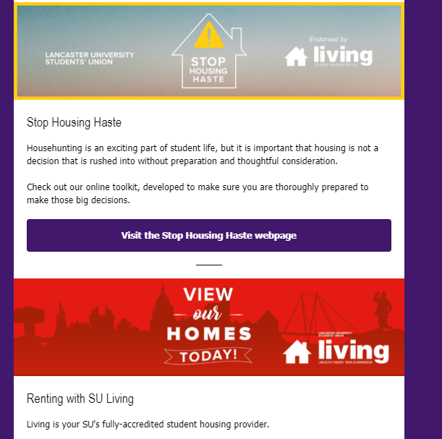
Figure 1 – a snippet from an email sent to Union members in November, and on other occasions
The Panel does not consider this conflicting messaging the fault of either Atree or other elected officers as they did not create such communications, though it could be argued that improved internal communication within the Union could have prevented such conflicting marketing from being distributed as displayed in Figure 1.
Also on Commercial Services, Atree pledged to work to lower the price of the Purple Card, while ensuring it had a better offering compared to existing student discount services. However, given falling numbers of Purple Card purchases in recent year, Coronavirus restrictions and other factors, the decision was made to end the Purple Card scheme. The Panel recognise that refunds were given to students who had a valid Purple Card and believe this was an ethical decision.

Democracy
A section of Atree’s manifesto focuses on how he would improve the Union in terms of democracy. In particular, Atree wanted to review the scrutiny panel system to improve accountability. As Scrutiny Officers, the Panel did not feel it appropriate to comment on this in detail, over than to say that they recognise attempts by Atree to reform the current scrutiny system.
Atree pledged to implement a set of student focus groups to improve overall student engagement, and also improve student engagement with the Union’s decision-making groups. The Panel feels that Atree has played a strong part in the efforts to improve Union democracy, including through the Union’s Democracy & Governance Review.
Atree pledged to improve communication through campaigning to tackle a lack of engagement in student politics. The Panel felt that while the Coronavirus pandemic may have hampered efforts to improve communication, through better communication from the Union is required and could be achieved through digital mediums. The Panel note that while improving communication through campaigning was a policy of Atree’s, there is desperate need for communication from the Union to be improved and this extends beyond his own job role.
Also, Atree pledged to review the Union’s affiliation with the National Union of Students (NUS). A referendum was held on the issue, and while it do not reach a quorum, the results showed that the majority of voters wished for the Union to remain affiliated to the NUS. The Panel recognise that Atree and other officers successfully achieved the pledge of holding a review on this issue and have respected the result of the referendum.

JCRs and PG Board Experience
A section of Atree’s manifesto focused on how to improve the JCRs and PG Board Experience. He pledged to develop a college focused strategy for the University and Students’ Union and increase collaboration with other collegiate universities. He has reached out to a former Pro Vice-Chancellor and worked with him to look at the role of colleges and where they sat within the structure of the University. This project is ongoing and will result in a report at the end, but some updates have already been made in terms of training and how the SU works with JCRs and colleges. He also managed to set up a network for communication between officers and JCRs, so officers can be in contact with what happens in every college throughout the year. The Panel recognizes that this was a very needed improvement, and will allow for greater collaboration and easier communication between the SU and colleges.
Another one of his pledges was to increase collaboration amongst colleges and update the JCR/PG Board committees to feed into a centralized plan. He has changed the training process for JCRs and how they work with each other. He is also working on changing the structure of the PG Board, as he recognizes that PG students work differently and have different needs than UG students. While this project hasn’t been finalized yet, the Panel appreciates Atree’s approach to working on improving the PG Board by exploring different structures until he finds one that fits. He also pledged to address the difference in relationships amongst different JCRs/PG Board and relevant SCRs to unify student experience and create a level playing field. He noted that JCRs generally tend to feel like they need to report to the SCR, and while he agrees that there should definitely be strong lines of communication, he is now working, as part of the new training for the JCRs to break that notion down.
Atree pledged to focus on improving flexibility of JCRs/PG Board funding and explore enrolment dependent budgets. After exploring this idea for a bit, he realized that it isn’t something that is needed and moved on to different projects. The Panel appreciates this, as it shows Atree’s ability to take feedback and adapt.
Another one of his pledges was to collaborate with JCRs/PG Board/PTOs to ensure events/social media are made entirely accessible and that required training is available. He has worked with the Students with Disabilities officer to create training for adding close-captions, image descriptions, etc. which is available on Moodle for people to use. The Panel appreciates that, especially as everything is happing online this year, this was very necessary and useful to ensure that all students can be included in events/social media.
Atree pledged to work with JCRs/PG Board to defend the college system and college spaces to ensure the student experience is not affected negatively by changes planned by the University. He noted that this is not a problem anymore, as the pandemic changed the University’s plans, so he has chosen to focus on other, more pressing projects, which the Panel appreciates. There is a question of what will happen once the pandemic is over, and the University is free to make those changes, but so Atree is still keeping an eye on any planned changes that might start happening.

Other Remarks, Overview & Recommendations
In his manifesto, Atree wrote that the SU is a testbed that the University can use to push changes on to students. He remarked that his opinion of this has improved and that, while it is definitely gradual, the SU is getting better at standing up for itself and for other students.
There is a clear issue within the SU that Atree identified, which has only been emphasised by the pandemic, and this is the way they communicate with students. Due to the restrictions, interacting with students face to face has been next to impossible, so the SU has relied mostly on online communications, which has led to low engagement from students on the different social media platforms. In the future, there is definitely a need for the Union to figure out ways to communicate effectively with students online, whether it is through newsletters sent by email, or just by social media. This is a union-wide issue and requires the entire union to act in order to improve it.
Atree has two projects that he wants to focus on this term: implementing Lancaster 100 (a student focus group aiming to improve student engagement) and the college focus strategy, which should both be implemented by the end of this term.

