Union Assembly Paper | Renaming Meeting Rooms in LUSU

Purpose of the paper | Determine the way in-which new names for the two meeting spaces within the Students’ Union offices shall be sought and selected.
Intended outcome | For discussion
Submitted and presented by | Rory O’Ceallaigh, LUSU President
Dependencies | Union Assembly
Persons / Bodies consulted | LUSU Staff
Confidential / Restricted | Open
Equality and Inclusion considerations | Through renaming the spaces, there is an opportunity (as has been taken at other SUs) to recognise marginalised inspirational figures.
Date paper produced | 02/03/2026

Following a reconfiguration of the existing Students’ Union office in Bowland Main, two new spaces have become available for student leader and student committee meetings. They are:
- The former Finance Office
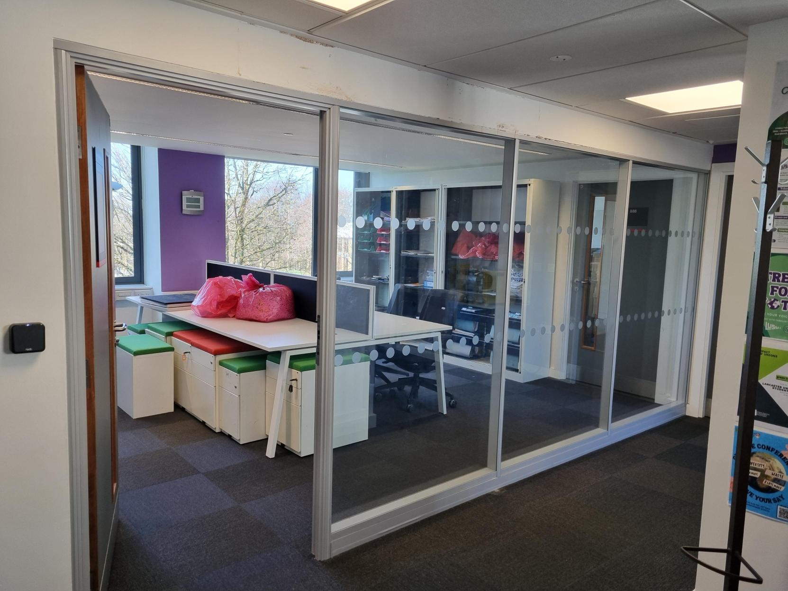
This space is directly within the name open office on B Floor. Furniture has not yet been changed, but it will be furnished as a normal meeting space.
The current plan is for this to be informally bookable (like the glass-walled space on A Floor) for all student leaders and volunteers within the Students’ Union.
MazeMap link: https://link.mazemap.com/GekqezAf

- The former Archive Storeroom
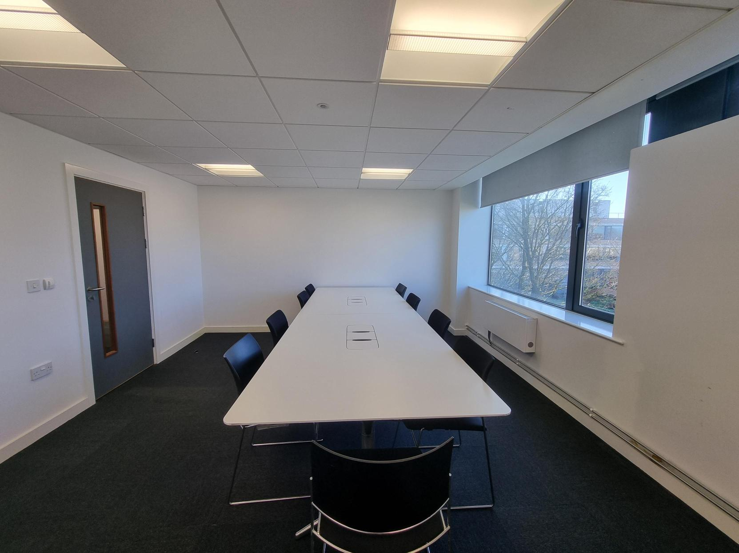
This space is situated on B Floor, between the open-plan office and the LUSU Boardroom, directly accessible via the stairwell.
It has been cleared and re-furnished as a meeting room. A large screen is due to be installed to allow hybrid or Teams meetings.
The current plan is for this to be informally bookable (like the glass-walled space on A Floor) for all student leaders and volunteers within the Students’ Union.
MazeMap link: https://link.mazemap.com/27EWgTls

Renaming
We are asking Union Assembly to decide how the rooms should be named. Our preference would be an open, democratic, and student-directed process.

